# PhytoNode - IoT Plant Health Monitoring System

A professional embedded systems project built with the ESP32. PhytoNode monitors a plant's vital environmental conditions (soil moisture, temperature, humidity, and light levels) and transmits the data wirelessly to a cloud dashboard, allowing you to monitor your plant's health from anywhere in the world.

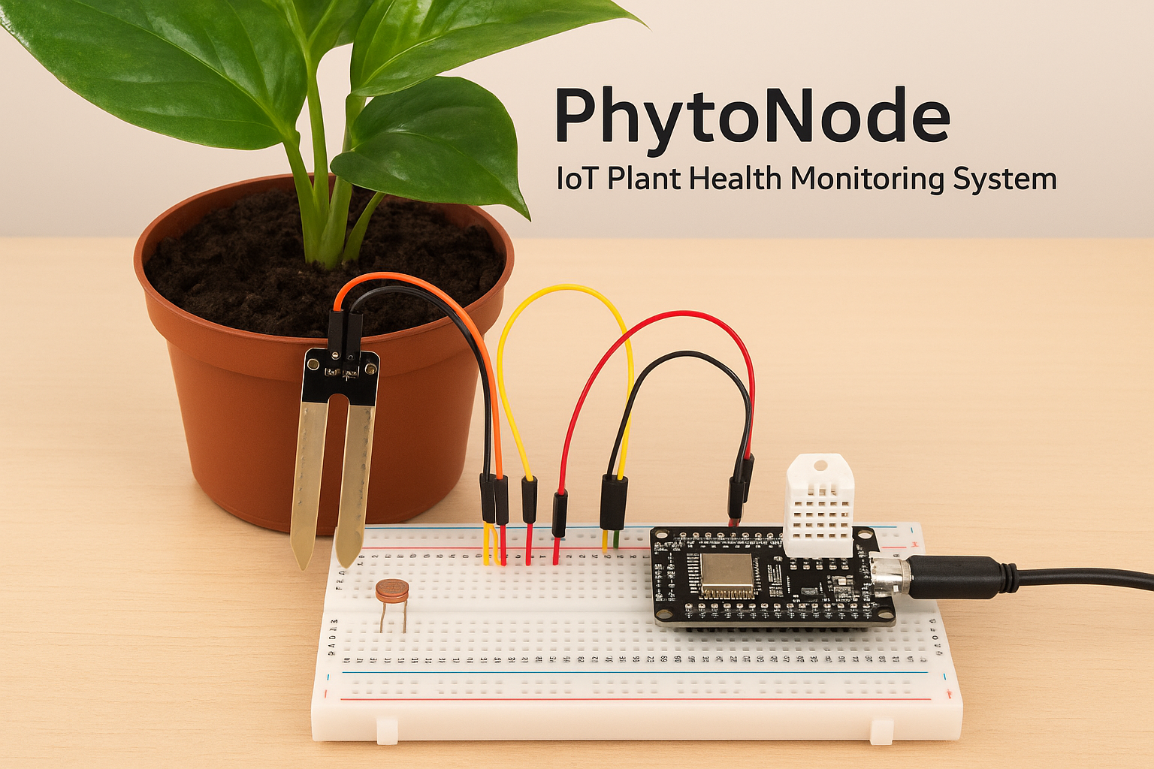

## 🌟 Features

* Real-time Monitoring: Continuously tracks key plant health metrics.
* Wi-Fi Connectivity: Uses the ESP32's built-in Wi-Fi to send data to the internet.
* Cloud Dashboard: Data is visualized on a professional web dashboard (ThingSpeak) with graphs.
* Battery Powered: Optional battery pack for true wireless, mobile operation.
* Error Handling: Robust code that handles sensor and network failures gracefully.

## 🛠️ Hardware & Wiring

### Components Needed

* ESP32 Development Board (1)
* Capacitive Soil Moisture Sensor (1)
* DHT22 Sensor (1)
* Photoresistor (LDR) (1)
* 10kΩ Resistor (1)
* Breadboard & Jumper Wires
* Micro-USB Cable (1)

### Optional for advanced version:

* LiPo Battery (3.7V)
* TP4056 Charging Module

### Circuit Diagram

The ESP32's 3.3V pin powers all sensors. Example wiring connections have been provided in the GitHub documentation.

## ⚙️ Software Setup

1. Install VS Code and PlatformIO.  
2. Clone the repository.  
3. Configure WiFi and ThingSpeak secrets in secrets.h.  
4. Upload the code using PlatformIO.  
5. Monitor sensor data via ThingSpeak Cloud.

## 📁 How the Code Works

1. Setup: Initializes sensors and WiFi.  
2. Main Loop:  
 - Reads sensors every 30 seconds.  
 - Publishes data to ThingSpeak via MQTT.  
 - Handles errors and retries automatically.

## 🔧 Calibration

Soil moisture and light sensors must be calibrated by recording raw values for dry/wet soil and dark/bright light conditions, then updating the map() function values in the code.

## 🚀 Troubleshooting

* Failed to connect to WiFi → Double-check SSID and Password in secrets.h.
* Failed to read from DHT sensor → Check wiring to GPIO 17.
* Data not updating on ThingSpeak → Check Channel ID and Write API Key.
* Soil moisture incorrect → Calibrate using dry and wet soil values.

## 📊 License

This project is open source and available under the MIT License.

## 📧 Contact

Your Name – gobikrishnan.pro@gmail.com

Project Link: https://github.com/KGobikrishnan//PhytoNode-Plant-Monitor